|  |
| --- |
| Heriot-Watt University |
| Design Report |
| Advanced Interaction Design F21AD |
|  |
| **Group 4: Sam Haley, Mary Holderby and Gordon Rennie** |
| **2/26/2019** |

**Note:** This document uses APA Referencing Format. (Details found at <https://www.ukessays.com/referencing/apa/>.)

Table of Contents

1 Background 2

2 Stakeholder and Task Analysis 2

3 Requirements Analysis 3

4 Storyboard Design 4

5 Prototype Development 6

5.1 Login Page 6

5.2 Home Page 6

5.3 Medication 7

5.3.1 Add Medication 8

5.3.2 Medication Details 9

5.4 Energy page 9

5.4.1 Breakdown of energy usage 10

5.4.2 Smart appliances 10

5.5 Exercise page 11

5.5.1 Add exercises 11

5.5.2 Exercise Run-Through 12

5.6 Smart Robot (Cozmo) 13

5.7 Settings 13

6 Appendix 14

6.1 Gantt Chart 14

6.2 Personae 15

6.2.1 Al – 15

6.2.2 Kitty - 16

6.3 Scenarios and Use-Case 17

6.3.1 Scenario 1 – Log-in Screen, User 17

6.3.2 Scenario 2 – Log-in Screen, Medical Staff 17

6.3.3 Scenario 3 – Log-in Screen, Spouse, children, relatives 18

6.3.4 Scenario 4 – Log-in Screen, Emergency Services 18

6.3.5 Scenario 5 – Log-in Screen, Maintenance 18

6.3.6 Use-Case for Cozmo Robot 18

6.4 Proposed Design for 1st February Presentation 20

6.5 Code for Cozmo Robot 22

6.6 Screenshots 22

6.7 Logbook 22

6.8 References 22

# Background

This is a design report for our proposal to build an interactive device for people generally of age 65+ with limited mobility. The specified requirements that this device should provide are – the support of exercise, reminders to take medicine at correct times, communication of energy use and tips to decrease this, and a mechanism to request a small robot fetch small items of use within the home.

Forlizzi and Battarbee (2004) described three types of interactions that could be produced between a user and a product: (1) an interaction which focuses on the product and requires some thinking or cognitive action from the user; (2) an interaction which fits into a user’s routine without interrupting it, termed ‘fluent’; and (3) an interaction which develops a relationship between the user and the product. Our concept for this design attempts to provide an effortless interaction so that the user can proceed with the daily tasks described above, while useful link to the helpful robot. This has led the design to provide ‘button’ icons which depict the function which pressing that ‘button’ will provide, movement through screens both deeper and return through use of direction mapping ‘buttons’, while allowing changes to the interactive screen options in terms of medicine and exercises. The intention is to make the screen facilities describe themselves to the user so there is no requirement to puzzle out or find the manual to know how to use the screens.

# Stakeholder and Task Analysis

The stakeholders who will be inputting and updating information for this device and who will be interacting through this device include:

* Individual in home: primary user
* Medical staff: doctor, nurse, therapists
* Spouse, children, relatives: may or may not be present
* Emergency services: ambulance, fire personnel
* Maintenance staff: home, utilities, robot, interaction system

In addition to the needs of the user of the interaction device, there is a log-in screen which permits secure access of support staff such as medical staff and maintenance staff so that their interaction can proceed after formal identification. But to make lot-in for the user as seamless as possible, this screen will recognise and accept the primary user via a retina screen and having passed that check once a day, the primary user is ‘remembered’ so that they do not have to repeatedly log-in. Medical staff, once logged-in, can make amendments to medicine requirements and exercise options, while maintenance staff can utilise their log-in to test the ‘smart’ home devices and make amendments to energy devices. Emergency staff who log-in can check on which medicines the user has taken that day and scan exercise usage to facilitate their helping the user in an emergency. Family members who log-in may similarly check that the user is taking their medication correctly and may even wish to join in some of the exercises which the user has been given in the device.

The location in which this device will be used:

* Primary use within home which has ‘smart’ device monitoring of energy use
* Secondary use within medical offices of doctor, nurse, and variety of therapist locations

It is expected that the device may need knowledgeable updates from such individuals as the doctor or nurse who can make medication changes and a therapist who may have new exercises to propose that the user should attempt for continued physical improvement.

The details of the personae for whom the interaction device has been designed appear in the Appendix as 6.2 Personae. The details of scenarios for the screen interaction and of the use-case for the robot interaction appear in the Appendix as 6.3 Scenarios and Use-Case.

# Requirements Analysis

Given the requirements listed in the Coursework specification – a mechanism to undertake exercise, reminders to take medication on time, information on home energy use with tips to minimise when desired, and a home robot to fetch items – plus requirements to support the stakeholders who want to support the primary user, screens were designed to support these functional areas. The functional areas were expanded with additional ‘supporting’ screens so that there was a complete provision of the function. Thus, the system is structured as:

* Log-in Screen (Scenarios: 6.3.1, 6.3.2, 6.3.3, 6.3.4, 6.3.5)
* ‘Home’ Screen
  + Medication
    - Medication Taken
      * Add Medication
      * Medication - Details
  + Home Energy
    - Weekly Energy Usage Chart
      * Energy in Use Now
      * Add Smart Appliances
  + Exercise
    - Available Exercises
      * Exercise Run-Through
    - Add Exercises
  + Robot
    - Ask robot to bring item
* Settings Screen

Simplicity and consistency was a key concept when coming up with a design for how the application was laid out. For this reason the home page was designed to convey as much information about the function of the application with as little text as possible. Large buttons with a “3D” effect have been used throughout the application to make it clear what can be pressed. Isakovic *et al.* (2016) utilized a questionnaire to consider some design criteria which included use of buttons which relied on simple images to convey their purpose. Furthermore, they chose colours which were muted and a lack of too many functions per screen in their design of an interactive device for older diabetics. The UK Government has provided useful design tips for all services which anyone with a disability may require to use (Pun, 2016). The poster designed people who have limited mobility included a requirement for screen elements to have a large space around them while not crowding interactions. These are pointers which we have implemented in our design.

All pages of the application use the same basic layout with the time shown in the top right corner, a back button if applicable in the lower left corner, settings / edit in the lower right corner and the main features in the middle of the screen. This adheres to the guidance given by the government for accessibility design (Pun, 2016) in that the layouts should be kept as simple and consistent as possible.

# Storyboard Design

The design as proposed for the presentation on 1st February 2019 is shown in the Appendix, as 6.4 Proposed Design for 1st February Presentation.

A number of alterations were made on the basis of the feedback received from the presentation and also on subsequent lecture material. One comment feedback to the team was that the proposed design did not notify the user when a designated time to take a medicine had been missed. Via the medications ‘taken’ screen, an amendment now flashes the ‘medicine’ icon on the ‘home’ page if it is time to take a prescribed medication. Noting the feedback that our design for exercises did not address providing motivation for the user to engage in exercise, additional research was conducted to pinpoint ways in which our personae – elderly people with limited mobility – might be motivated. One observation found in several websites is that people will tend to do an activity or exercise if it is something they enjoy (Baylor Scott & White Health, 2012; Myers, 2015). Two sports highlighted by Myers (2015) as enjoyed by older people are golf and bowling. These sports, bowling and golf, were added as exercises available to ‘add’ via the ‘add exercise’ screens. Rather than hindering participation due to lack of equipment, the exercises would make use of sensor substitutes that would help track whether the movements undertaken would help the player ‘win’ at the sport.

An additional feedback comment from the presentation of our design was that our energy screens did not encourage engagement with the further observation that our screens did not contain an indication of daily usage which might be a motivation to interact with the energy displays. Amendments were made to the energy use screens; instead of a building ‘floor plan’ for energy use in each room, one week’s set of bars were used with the lower portion showing actual use for the day as opposed to average use for that day. A ‘tip’ has been added below the bars with a suggestion of how energy consumption might be lowered. A further interaction has been added so that the user can select the usage bar of a given day and be shown how the energy has been used, with a further comparison to usage on that day for each of three weeks previous. The second screen was amended to remove the ‘floor plan’ and offer a simple method for adding/deleting a ‘smart appliance’.

Following a course lecture regarding security, the group agreed the interaction design needed a log-in screen for our interactive design panel. To make this log-in as effortless as possible for the user, we built the screen to include a facial-recognition camera so that the user would not have to remember a password. Recognizing that there are other stakeholders, such as medical and maintenance staff, we added a log-in input so that they could interact with the system but only after passing the security check of entering the correct details.

# Prototype Development

## Log-in Screen

The ‘log-in’ offers a secure mechanism for both the user and all stakeholders to interact with the system. For the user, by looking into a camera which offers facial recognition, there is no need to know or enter ‘password’ details to gain access. For the stakeholders, though, a password assigned to their specific area of system usage ensures that they can access the parts of the system that they need to. For instance, medical staff, such as a doctor or nurse are taken to the ‘Add Medication’ screen once they have provided the correct details at ‘log-in’. The scenarios for interaction with this screen are included in the Appendix as 6.3.1 Scenario 1 – Log-in Screen, User; 6.3.2 Scenario 2 - Log-in Screen, Medical Staff; 6.3.3 Scenario 3 - Log-in Screen, Spouse, children, relatives; 6.3.4 Scenario 4 – Log-in Screen, Emergency Services; and 6.3.5 Scenario 5 – Log-in Screen, Maintenance. The prototype screen is in the Appendix as 6.6.1 Log-In Screen.

## Home Screen

The home screen has five buttons each colour coded to ensure easy identification:

* Green, medication button will take the user to the medication page of the application (see 5.3 Medication). This button will also pulse along with a chiming sound when it is time to take a given medication.
* Red, energy/smart home button will take the user to energy page of the application (see 5.4 Energy Page). This is where users can monitor their energy usage and get tips on how to become more energy efficient.
* Blue, exercise button. Takes the user to a personalised exercise page with exercises tailored to the user’s specific needs. (see 5.5 Exercise Page)
* Purple “robot” button to get access to the smart homes assistant robot. (see 5.6 Smart Robot)
* Settings button, this allows the user to tailor the look and feel of the application to fit with their needs, such as colour blindness. (see 5.7 Settings)

## Medication

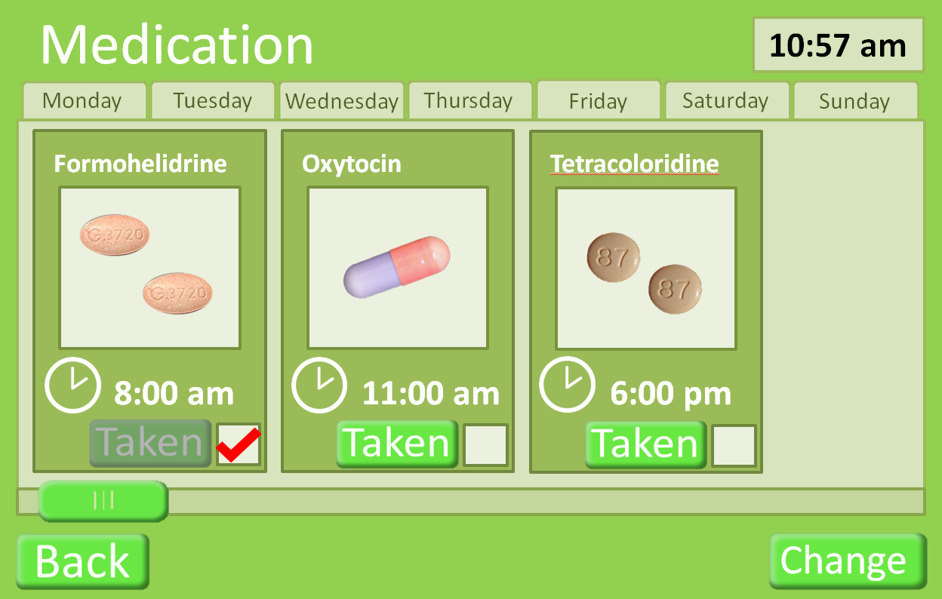

Can press the image of the medication to give more detail of the medication (see 5.3.2 Medication Details).

Press to change medication (see 5.3.1 Add Medication). This would be expected to be done with a doctor.

Press “taken” button when medication has been taken.

Figure - The primary Medication Screen. This screen permits the user to 'tick' a medication taken. It provides a visual representation of the pill, along with the medication name and the time that the dosage should be taken.

In “8 Creative Ways to Remember” (2014), a number of tips are given to help remember to take medicine on time. One suggestion is to use a picture of the medication as it makes regular dosage part of a day. This is a practise our design has employed, enhancing the pictures with the option to view what side effects may be and what the medication is treating. The design has included these so that emergency services personnel can access the information as can a doctor or nurse; this can help forgetful patients who may have many different medications to keep track of.

The medication page shows the user what medication should be taken on any given day, selected by the tabs at the top of the display; it defaults to the current day. This page was designed to give only as much information as the user needs to take the medication. Hence, it shows: what the drug looks like and how many to take, the time it should be taken (if the user has not taken the medication by the set time the medication button on the home page will pulse and a chiming sound will be heard) and if the user has taken the medication yet that day.

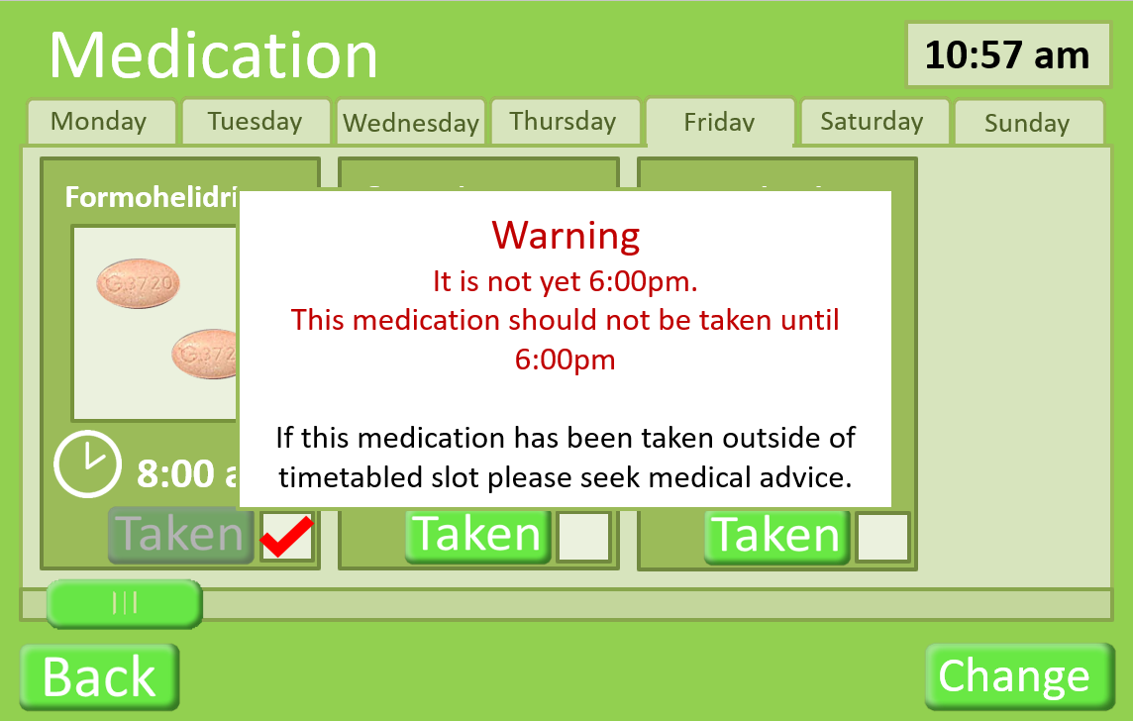

Figure - This shows a warning overlay which occurs if the user attempts to tick that they are going to take a medication before the correct time has been reached when it should be taken.

### Add Medication

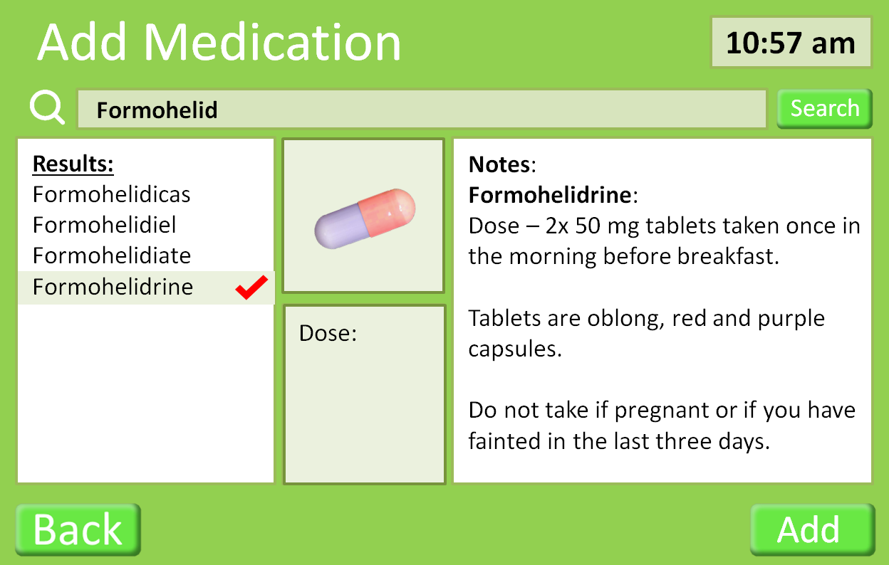

The Add button adds the drug to the user’s medication.

Details of the selected drug

The correct drug can be selected from the results.

Drugs can be searched for in the database.

Figure - The Add Medication screen provides a list of matching medication names against a search phrase. It provides information about the dosage and any contraindications.

This page is used in conjunction with a doctor. Drugs can be searched for and added into the user’s medication.

### Medication Details

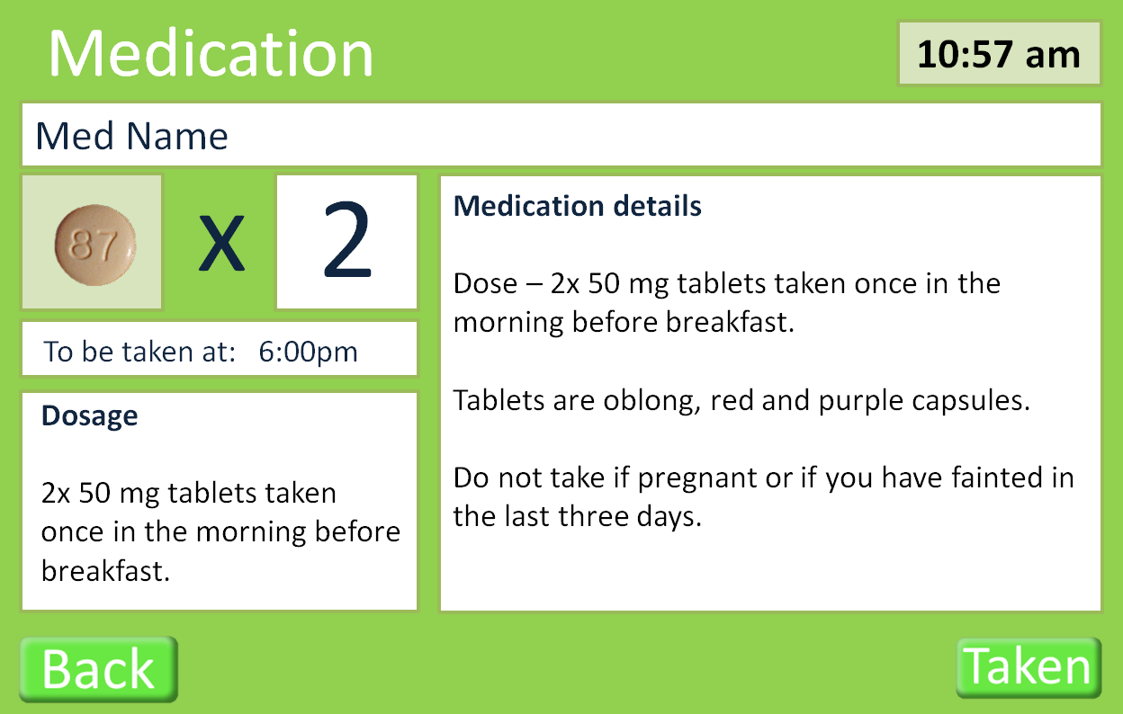

Figure - The Medication Details screen gives an additional screen which can give the user information and a visual image of the associated tablet. It offers the user a mechanism to reassure the user that they are taking the right medication.

This page shows the full details of a specific medication.

## Energy page

This page will be updated

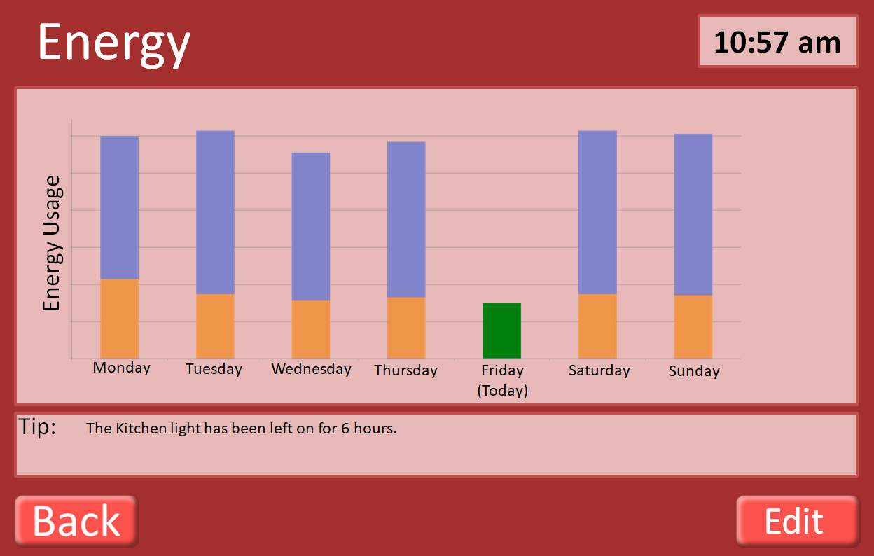

Total energy usage

Energy usage at 10:57am on given day

Edit button allows user to add smart devises to be tracked (see 5.4.2 Smart Appliances)

Figure - The primary Energy Usage screen shows a week of bars which indicate total energy use that day with current use. Any helpful tips as to cutting back usage appear using information from the 'smart home' monitoring system.

This page indicates the energy usage by the user over the past week. It also indicates how much energy had been used by the same time each day of the week. The application also tracks how long devises have been on and tries to prompt users to turn of devices that are not being used.

### Breakdown of energy usage

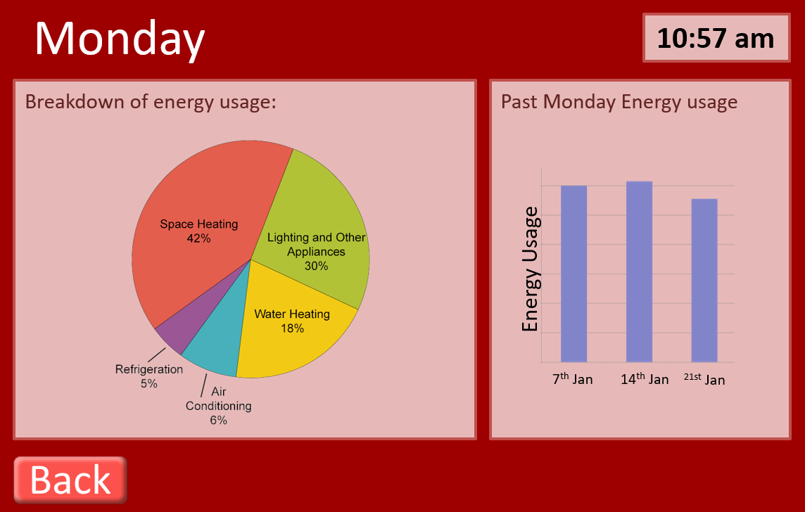

Figure - This screen is displayed when the user taps a bar for a given day on the primary Energy page. It gives information about how energy is being used in the home up to that time. It also compares usage for the same day through the previous 3 weeks.

### Smart appliances

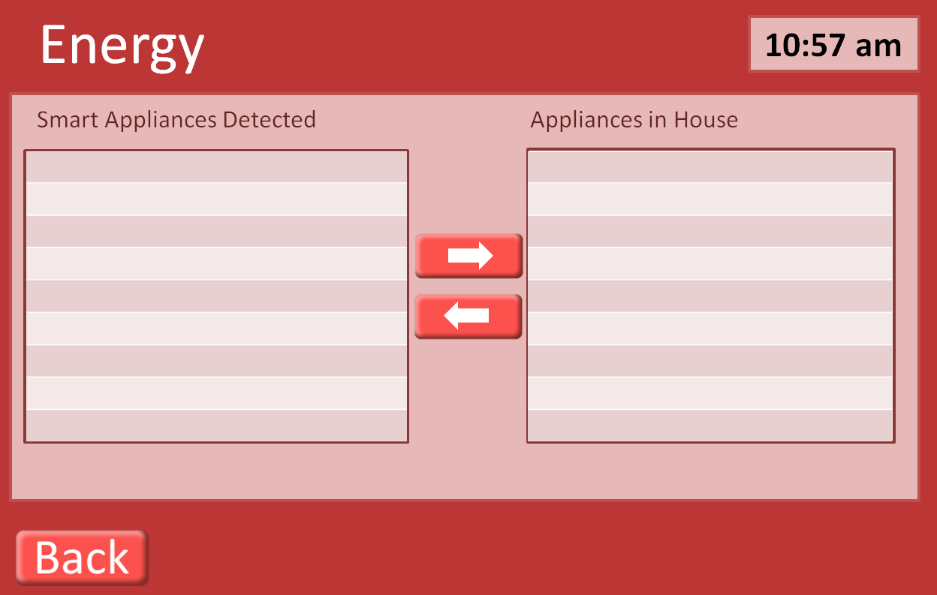

Use arrows to add remove devices from being tracked for energy usage.

Figure The Smart Appliance Screen shows the 'smart' appliances that the monitoring system has found to be in use and provides the addition of further devices to be monitored. These devices are monitored to give the user control over their energy usage.

This page is used to provide the user with the ability to add devices to be monitored by the application. Smart devices are automatically detected, shown in the Smart Appliances Detected, and can then be added to the home using the arrow buttons.

## Exercise page

The exercise page shows a list of exercises/activity’s that are tailored the user’s specific requirements. The NHS recommends that older adults (65+) partake in two different types of activity every week: a mixture of aerobic activity such as cycling or walking along with strength exercises, that impact all parts of the body, including legs, hips, back, abdomen, chest, shoulders and arms (NHS, 2019). Several specific exercises are shown in the storyboard and prototype of the design proposal.

The group discussed the possibility of Tai Chi, which appeared in China in the 13th century as a martial art, as a possible appropriate exercise. There is evidence that practicing Tai Chi can help older adults to reduce stress (Sandlund & Norlander, 2000), improve posture and balance leading to lower risk of falls (Lomas-Vega, Obrero-Gaitan, Molina-Ortega, & Del-Pino-Casado, 2017). Most importantly for those with mobility issues or who are unable to stand Tai Chi can also be practiced sitting down, bring about much the same health benefits as when done standing up (DailyCaring, 2019).

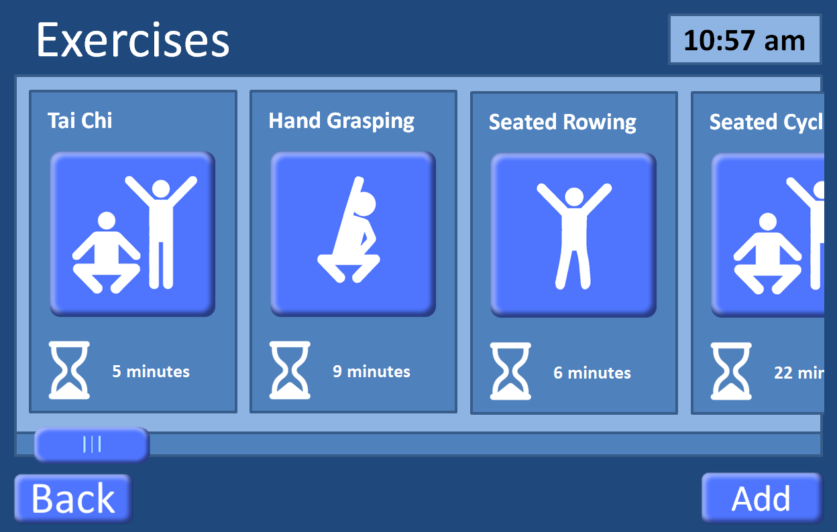

Press to add/ remove exercisers to the personalised list (see)

Indicates expected time needed for exercise

Press to start exercise

Figure – The main Exercise screen shows exercises which are available in the system for the user to participate in. It provides a time-to-complete guidance under each exercise. The ‘Back’ button takes the user to the previous screen (5.2 Home Page).

Exercises hang off the end to indicate that the user can scroll. Scrolling can be done two ways: standard touchscreen hold and drag, or by using the scroll bar at the bottom.

### Add exercises

This image will be updated

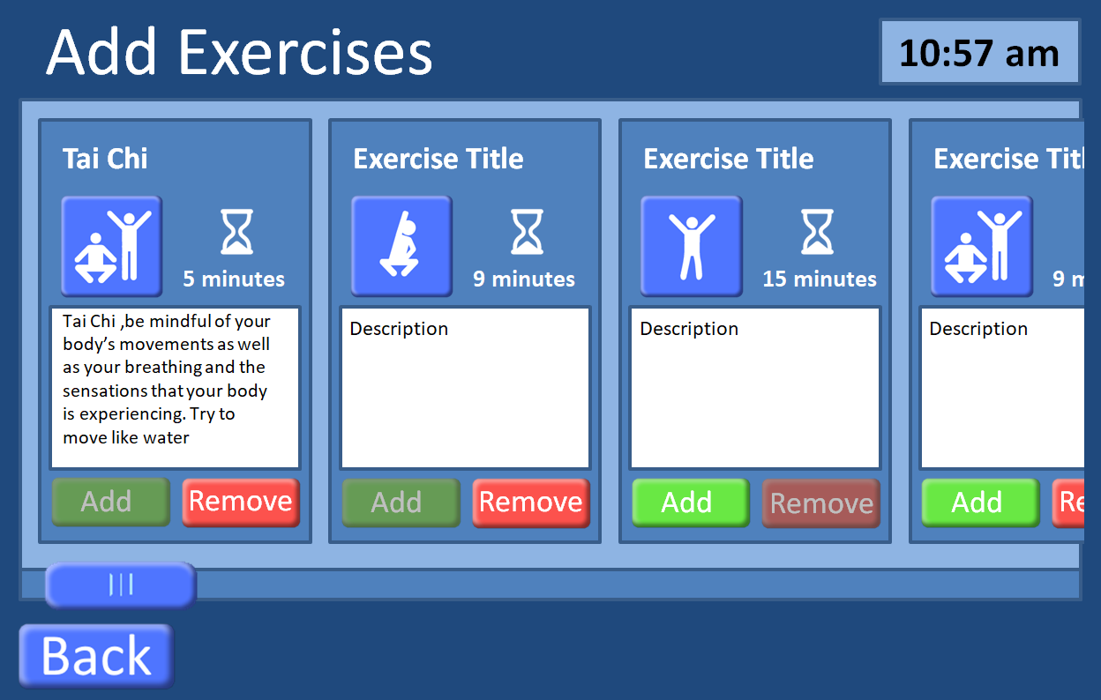

Press exercise button to view a run-through of the exercise to see if suitable (see 5.5.2 Exercise Run-Through).

Figure - This is the screen through which to add new exercises. A description is given along with a time-to-complete guide. Baylor Scott & White Health (2012) have highlighted that an appropriate medical assessment should be made so that a user knows the exercise is one that they can do.

Exercises can be added or removed based on recommendations from doctors and personal preferences of the user.

### Exercise Run-Through

Countdown timer showing how long a position must be held.

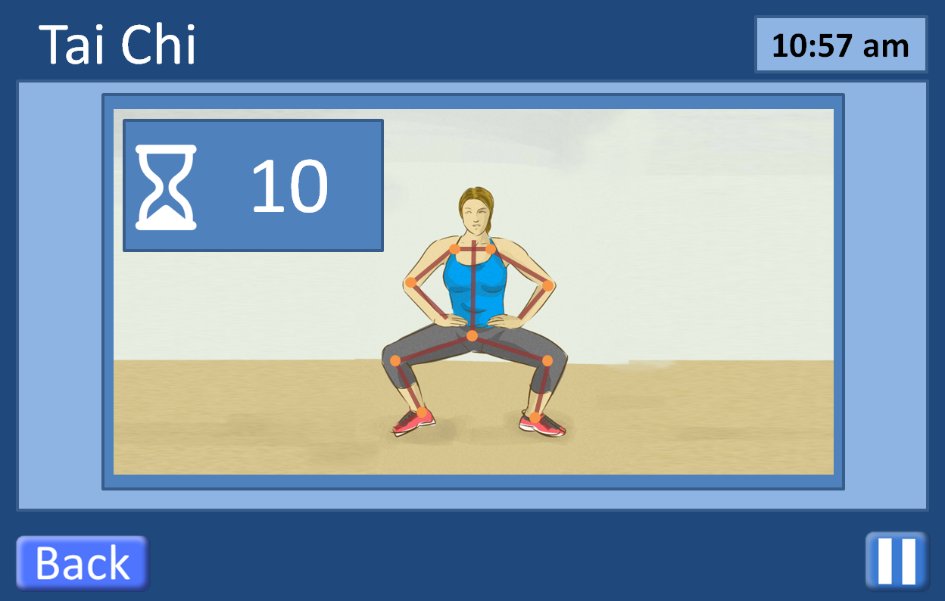

Exercise can be paused at any time

Overlay of user showing how closely they are matching the correct positions

Figure - This is an example of a specific Exercise screen. In the example, a movement in the Tai Chi exercise sequence is demonstrated by an image with an overlay of sensor points on the body to help the user identify where their arms and legs should be while performing this movement. The image and sensor points as an overlay were used as a mechanism to show rather than explain with words.

The choice of icons for the exercises came from ‘Just Dance’ video sequences Exercises work by having an animated video of a person doing the activity with an overlay of the user giving immediate feedback on how well the user is doing. Overlays may also appear on screen showing for instance how long the user must hold a certain position. The user can leave the exercise by pressing the back button which will take the user to the previous page (either 5.5.1 Add exercises or 5.5 Exercise page).

As the product was to give interaction, the initial design of exercises focused on giving the user feedback in the form of a human image with line skeleton overlaid and sensor points on that line skeleton. The display was expected to guide the user through placement of the line skeleton through a given exercise sequences and the sensor points on the screen would be mirrored in sensor devices on the user’s body. The feedback highlighted in the initial design could be seen as ‘passive’ in that it relied on the persona mirroring the skeleton outlining the position of the exercise. The amended exercise feedback will show colour areas on the panel form – a red colour on the panel form’s arm, for instance, will suggest that the persona’s position of the arm during the exercise is out of alignment with what is needed, a green colour on the panel form would feedback to the person that their position for this part of the exercise movements is correct. The group felt that this was an improved feedback mechanism and again was done through displaying ‘green’ for ‘correct’ and ‘red’ for ‘incorrect’ as non-verbal encouragement to the user. Non-verbal communication overcomes the potential for confusion from a series of words and practises the UK government guideline to not create ‘walls of text’ (Pun, 2016).

## Smart Robot (Cozmo)

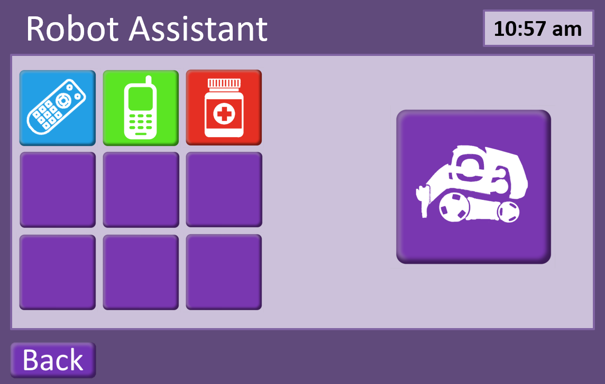

Figure - This is the Smart Robot screen. On this screen the user selects an item for the robot (Cozmo) to retrieve and it is through this screen that both Cozmo and the user interact to confirm the item to be retrieved and to confirm that the right item has been retrieved.

## Settings

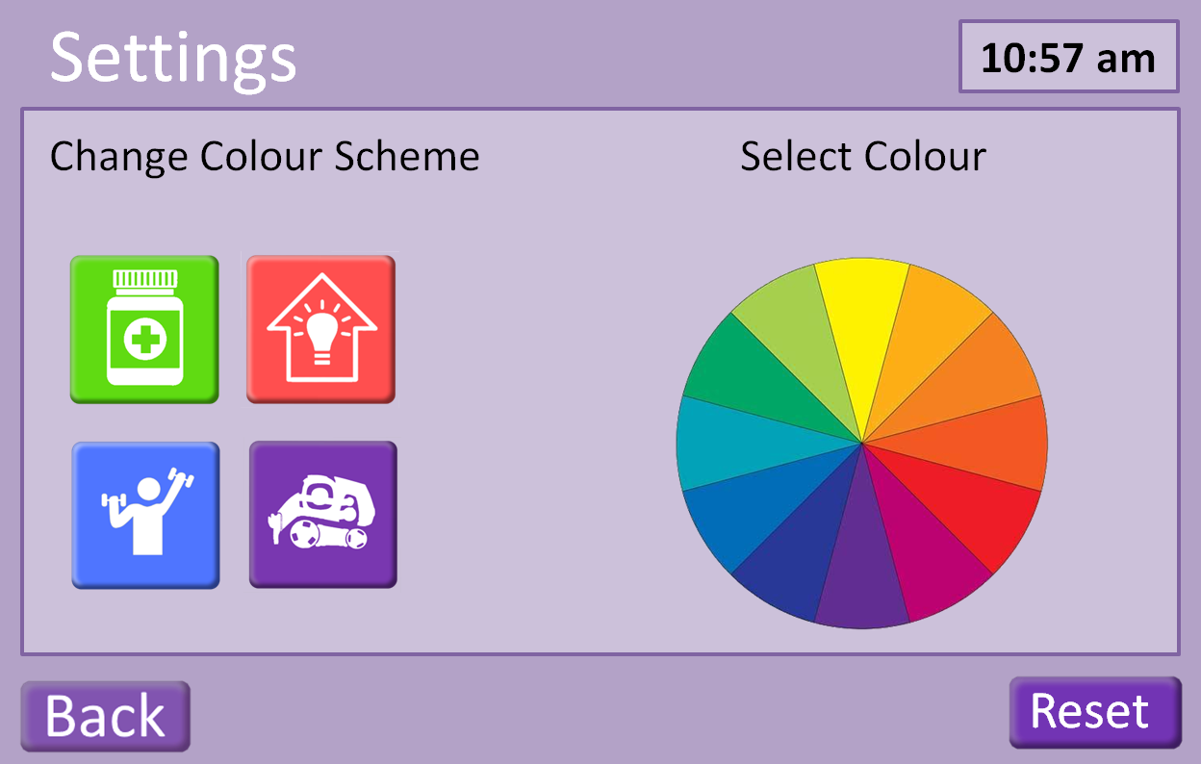

Figure - This is the Settings screen through which the user may change the colour palette of the screens and buttons displayed in the Interactive Screen. By pressing the 'Reset' bottom at the lower right, the colours are returned to their defaults.

# Appendix

## Gantt Chart

|  |  |  |
| --- | --- | --- |
| **Task** | **Start Date** | **Days to Complete** |
| Indrocutory and planning (meeting) | 22-Jan | 1 |
| Lit. review | 23-Jan | 6 |
| Persona Building | 23-Jan | 6 |
| Storyboard Design Planning (meeting ) | 29-Jan | 1 |
| Storyboards (Iteration 1) | 30-Jan | 6 |
| Review of Storyboards (meeting) | 05-Feb | 1 |
| Storyboards (Iteration 2) | 06-Feb | 2 |
| Presentation of Storyboards | 08-Feb | 0.5 |
| Introduction to cozmo | 08-Feb | 0.5 |
| Building Cozmo Code (SDK) | 09-Feb | 10 |
| Review of Prototype and Cozmo (meeting) | 12-Feb | 1 |
| Write Report | 12-Feb | 10 |
| Final review of Prototype | 19-Feb | 1 |
| Final iteration for development | 19-Feb | 2 |
| Presentation (Final) | 22-Feb | 1 |
| Review of Group Report (meeting) | 22-Feb | 1 |
| Finalise group report | 22-Feb | 3 |
| Submission of Group Report | 26-Feb | 1 |

## Personae

### Al –

Age : 66

: Widowed, 8 years

: 1 adult daughter, married with small children, lives in Australia

Health : Suffered first stroke six weeks ago

Al does not smoke, drinks moderately (2-3 beers a week, some weeks no drinks). A recreational cyclist, Al also likes to swim. Does not follow sports. Has been active with his church and has taught in Bible classes for ages 8 – 12, for a number of years. After retirement, he also began to work with the same age (8 – 12) group with a neighbourhood refugee support organization.

Worked 40+ years for an architectural/building firm. Initially worked as a mechanical engineer, but then as mechanical designer. He is in demand there as an occasional trainer for new employees in the mechanical design department. Because of his past design work, Al enjoys drawing and watercolour painting.

Consequences of stroke: minor speech impairment which has largely been overcome through therapy. Difficulty in walking and difficulty in assessing placement of objects/hands to place objects.

Was in a rehabilitation unit where some progress (mainly speech) was made. However, Al is in denial about the stroke and this means he is often distracted and/or depressed. 1 week ago he mixed up when to take his medication and this led to a minor medical reaction. This seems to have depressed him further. Al has moved to assisted living accommodation but he struggles with the results of the stroke in terms of being motivated to improve his health.

Next stages for improvement

: Al wants to be in his own home but to do this he needs to be able to

1. Walk through rooms, to bathroom, to kitchen. At present, he has difficulty doing this.

* Needed: Exercises to improve muscle strength, balance coordination, overall activity.

1. At present, in addition to walking problems, Al is often unable to grasp and control many home implements such as cooking utensils and has to rely on a ready-meal delivery system and also unable to draw or paint because of the lack of hand control. He finds the process to make his hands do as he wants very frustrating.

* Needed: Exercises to improve control and coordination of hands.

1. Take medication on time. Initial assessments have shown Al is depressed with his recent stroke and feels out of control over what matters to him. This in turn leads him to not act according to instructions, such as on medication. He presently has several types of medicine that need to be taken at specific times but despite labels on containers, Al failed to take one medicine correctly which led to some minor deterioration.

* Needed: A method that makes it easier for Al to take his medication at the right times.

1. Because Al has difficulty in walking, he needs extra assistance getting small, everyday items.

* Needed: A robot which could take instructions – ‘Bring me my glasses’, for example – would ease Al’s transition to being fully independent in his home again. Items that may be needed for a robot to fetch include: aforementioned glasses, pen and paper, mobile telephone.

If these four areas can see real improvement in Al’s ability to regain independence, it could make a positive difference to Al, who deeply misses feeling like a functioning adult with much to give to others.

*Nice to have:*

Given that Al has worked for a building company as a mechanical engineer and now designer, he would enjoy checking his use of heating and electricity of his environment. It would tie in with his past employment and give him an element of control over his life, something he feels he has lost with the stroke and its effects.

### Kitty -

Age : 78+

: Widowed, 23 years

: 3 adult children, married, 5 grandchildren

Health : Kitty uses a walker after a fall caused back damage.

Kitty gets less exercise than she once did and as a consequence her balance is deteriorating.

Kitty worked a cook for a hotel restaurant until retiring at age 59. She likes puttering around in a small garden and playing card games with the ladies at the local centre for pensioners.

Kitty is forgetful so can miss a dose of prescribed medication without reminders.

Next stages for improvement

: Kitty enjoys her independence as well as her social group at the local centre.

1. Kitty knows she should exercise more and accepts that if she doesn’t, she may lose the ability to visit the local centre.

* Needed: Exercises to improve muscle strength, balance coordination, overall activity.

1. Kitty enjoys when her grandchildren can come for a visit. She is sad when she cannot lift them to sit with her but she doesn’t handle weights very well.

* Needed: Exercises to improve arm tone through light weight lifting.

1. Take medication on time. Kitty is forgetful and often confuses her medication.

* Needed: A method that Kitty can easily follow to check off which tablets she has taken and which still need taken at what time would help her in this.

1. Kitty would enjoy extra assistance getting small, everyday items. She did have a home helper who came three times a week but the council had to cancel that as they no longer had the funds to pay the helper. Kitty misses the interaction.

* Needed: A robot might give Kitty an interaction in her home that would help give her social exercise.

*Nice to have:*

Kitty has said that she’d like to save a few pennies here and there and has wondered whether her home utility usage is a possible place to save a bit. Some tips along with a measure of how much she uses might help her.

### Joe

Age : 71+

: Widowed, 2 years

: 3 adult children, married, 4 grandchildren

Health : Joe has heart problems which have left him breathless from

minimal exertion.

Joe has enjoyed playing bowls in the past and misses his bowls team.

Worked on trains and goods department of rail company.

Next stages for improvement

: Joe needs to engage in exercise as it is hoped he can rebuild his stamina and breathing ability. But this requires slow and steady exercise.

1. Walk through rooms, to bathroom, to kitchen. At present, he has difficulty doing this without becoming breathless.

* Needed: Exercises to improve stamina, encourage use of legs.

1. At present, in addition to breathing problems that result from lack of exercise, Joe misses the socialization he once he enjoyed with his bowls club.

* Needed: Any exercise that would encourage arm movement, similar to what would be needed to play at bowls.

1. Joe is forgetful but has a variety of tablets that he needs to take on a daily basis.

* Needed: A method that makes it easier for Joe to take his medication at the right times.

1. Because Joe can become breathless even to fetch small items within his home, he needs extra assistance getting small, everyday items.

* Needed: A robot which could take instructions – ‘Bring me my glasses’, for example – would ease Joe’s transition to being fully independent in his home again. Items that may be needed for a robot to fetch include: aforementioned glasses, pen and paper, mobile telephone.

If these four areas can see real improvement in Joe’s ability to regain better health, it could make a positive difference to Joe.

*Nice to have:*

Joe considers himself very ‘thrifty’ and ‘energy’ conscious. A mechanism that would report on his current usage with motivation to reduce it might be something Joe could engage with – a type of ‘competition’ with his previous energy usage.

## Scenarios and Use-Case

### Scenario 1 – Log-in Screen, User

* User approaches Interactive Device to ‘Log-In’ to system.
* Their retina is scanned from the screen.
  + If retina matches file for user, user is considered ‘logged-in’ and the Home screen menu is presented.
  + If retina does not match file for user, ‘Log-in’ Screen remains displayed.

### Scenario 2 – Log-in Screen, Medical Staff

* Medical staff member approaches Interactive Device to ‘Log-In’ to system.
* They enter their details on the screen.
  + If their details match those on file for medical staff, individual is considered ‘logged-in’ and the ‘Medication’ screen is presented for checking. From this screen, they can select the button labelled ‘Change’ located at the bottom right. This will take the individual to the ‘Add Medication’ screen for amendments.
  + If their details do not match those on file for medical staff, the ‘Log-in’ Screen remains displayed.

### Scenario 3 – Log-in Screen, Spouse, children, relatives

* Family member or relation approaches Interactive Device to ‘Log-In’ to the system.
* They enter their details on the screen.
  + If their details match those on file for family member or relative, individual is considered ‘logged-in’ and the ‘Medication’ screen is presented for checking. From this screen, they can only select the ‘Back’ button to return to the ‘Home’ screen. From here, they can select ‘Exercises’ if they wish to discover what exercises are available.
  + If their details do not match those on file for family member or relative, the ‘Log-in’ Screen remains displayed.

### Scenario 4 – Log-in Screen, Emergency Services

* Member of the fire or ambulance services approaches Interactive Device to ‘Log-In’ to the system.
* They enter their details on the screen.
  + If their details match those on file for the fire or ambulance services staff, individual is considered ‘logged-in’ and the ‘Medication’ screen is presented for checking. From this screen, they can press the display of a medication shown to learn more details.
  + If their details do not match those on file for the fire or ambulance services staff, the ‘Log-in’ Screen remains displayed.

### Scenario 5 – Log-in Screen, Maintenance

* A maintenance staff member approaches Interactive Device to ‘Log-In’ to the system.
* They enter their details on the screen.
  + If their details match those on file for a ‘smart home’ maintenance staff member, they are taken to the ‘Smart Appliances’ screen where they can add an appropriate appliance.
  + If their details match those on file for the application maintenance staff member, they are taken to the ‘Settings’ screen where they can undertake system maintenance.
  + If their details do not match those on file for either a ‘smart home’ maintenance staff member or an application maintenance staff member, the ‘Log-In’ Screen remains displayed.

### Use-Case for Cozmo Robot

Use case for Cozmo

Communication button

Showing what cozmo is doing

#### Ideal Path

1. User selects Cozmo tile on home screen of app.
   1. Cozmo boots up, app shows ‘waking’ screen
   2. Cozmo finds cubes and confirms which he can see
   3. Objects are displayed on app screen for selection
   4. Cozmo says “Ready when you are!” and spins on the spot
2. User selects one object
   1. Obejct is shown on the centre of screen, green tick appears in communication box
   2. Cozmo says “When you’re sure that’s the one you want. Press the tick, if you want to select another, just press on another object.”
3. User presses the tick
   1. Cozmo says “OK, I’ll be right back.” Cozmo whistles as it moves to the selected object.
   2. Centre of app screen shows cozmo moving. Communication button shows a cancel button
   3. Cozmo picks up object and says, “Got it!”
   4. Cozmo brings the object back to the user
   5. Cozmo says “This is the right one, right?”
   6. Communication button shows a tick and a cross
4. User presses the tick
   1. Cozmo says, “YAY!” and plays a trumpet sound
   2. Cozmo asks for a fist bump
   3. Cozmo asks, “Do you want me to fetch anything else?”
5. User returns to the home screen
   1. After five minutes of inactivity Cozmo says “I’m going to go back on charge now, let me know if you need anything.”
   2. Cozmo returns to its cradle and powers down.

#### Deviations from Ideal Path

##### Overarching issues:

Cozmo is off its charger and is out of power. When Cozmo is selected from home screen, app displays a warning saying, “Cozmo needs put back on his cradle and charged before it can be used.” Once Cozmo is placed back on its cradle the app will display its current power levels. Cozmo cannot be sent on new tasks if it is under 10% charge.

1b) Cozmo cannot find any cubes on boot up. App displays empty object panel and message saying “Cozmo can’t see anything it can fetch around it. Make sure any objects you want Cozmo to fetch for you are on the same surface as it.” Button is displayed under message saying, “Search for cubes again.”

3a) Cozmo cannot find route to selected object. If Cozmo becomes stuck or cannot reach object it will say, “Rats, I can’t seem to get to that one, can you see anything blocking my way?” The communication box on the app screen will then show a tick or a cross.

## Proposed Design for 1st February Presentation

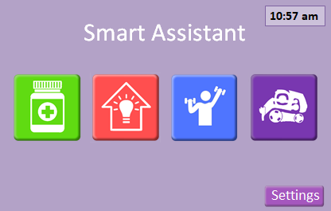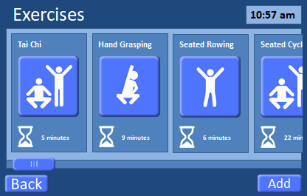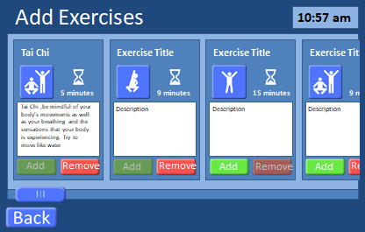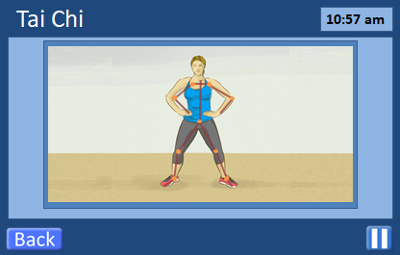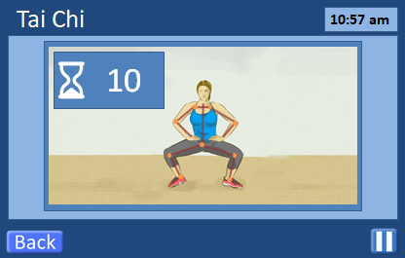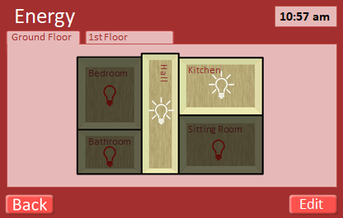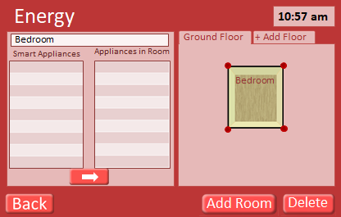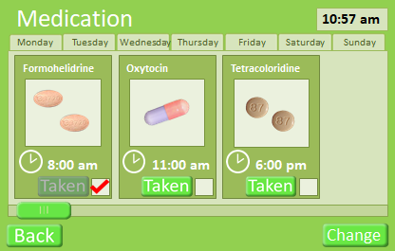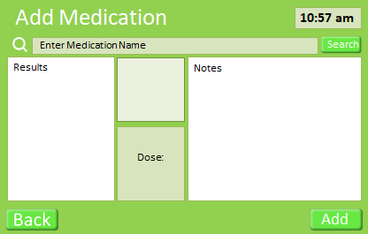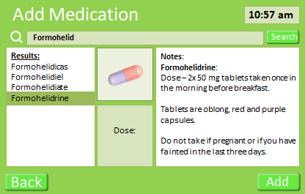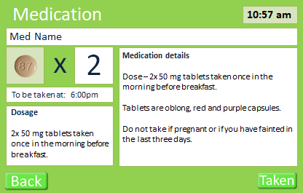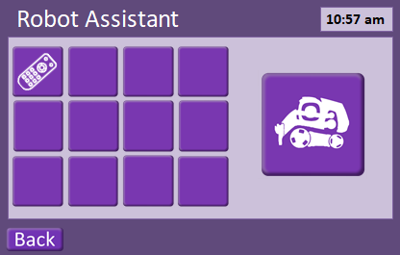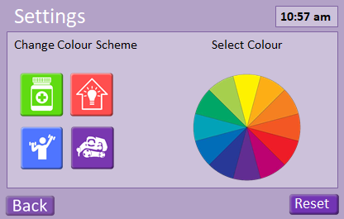

## Code for Cozmo Robot

## Screenshots

### Log-In Screen

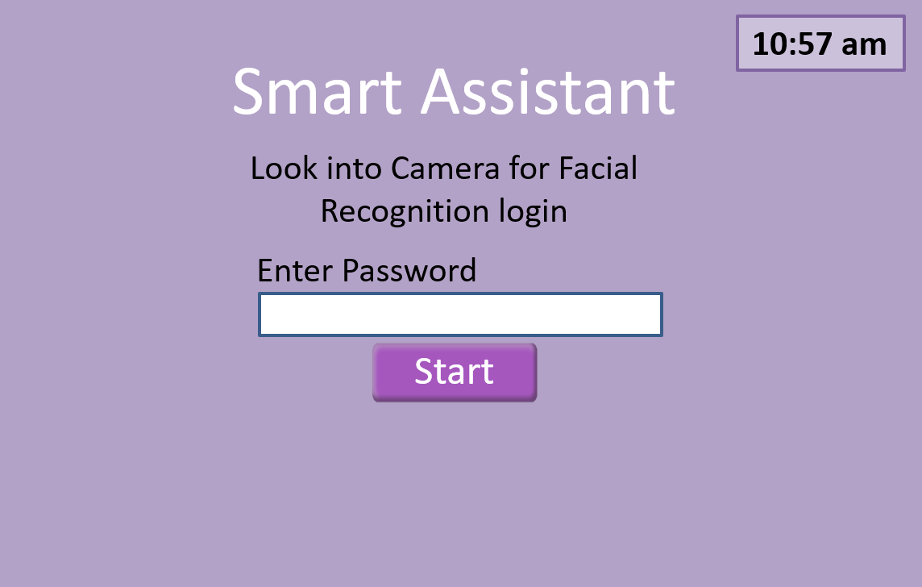

Figure - The Log-in screen for the Interactive Display. The user only has to look into the camera which will have face recognition software; this will save the user from having to remember and enter a log-in password. Other stakeholders will be required to enter a password for access.

### Home Screen

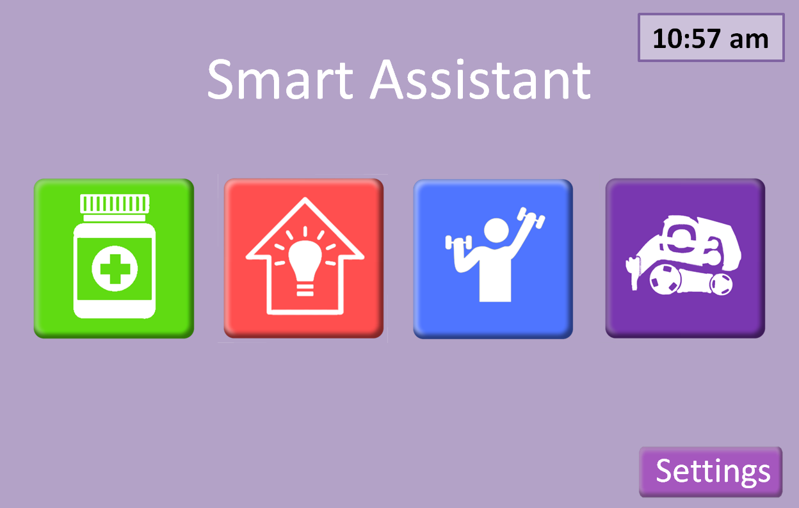

Colour coded buttons with “3d” effect to clearly indicate that they can be pressed.

Figure 2 - shows the homepage for the Interactive application. The four square buttons represent the four areas of interaction available to the user.

## Logbook

## References

8 Creative Ways to Remember to Take Your Medicine Every Day. 3 August 2014. Retrieved 17 February 2019 from <https://www.drugs.com/article/taking-your-medicine.html>.

Baylor Scott & White Health, (2012, 30 July), Hands-On Health Care Discussions. Scrubbing In: Tips for encouraging the elderly to exercise [online]. Retrieved 2 February 2019, from <https://scrubbing.in/encouraging-the-elderly-to-exercise/>.

Culén, A. L., & Bratteteig, T. (2013). Touch-screens and elderly users: A perfect match? *Changes.* *7*(15) 460-465.

DailyCaring (2019). Seated Tai Chi for Seniors: 3 Simple Routines Improve Flexibility and Well-being [online]. Retrieved 29 January 2019, from <https://dailycaring.com/seated-tai-chi-for-seniors-3-simple-routines-improve-flexibility-and-well-being-video/>.

Forlizzi, J., and Battarbee, K., (2004). DIS ’04 Proceedings of the 5th conference on Designing Interactive systems: processes, practices, methods, and techniques. Cambridge, Massachusetts, USA, 1 – 4 August 2004. Pp. 261-268. Available at: doi.10/1145/1013115.1013152.

Isakovic, M., Sedlar, U., Volk, M. & Bester, J. (2016) Usability Pitfalls of Diabetes mHealth Apps for the Elderly. *Journal of Diabetes Research 9.* <https://doi.org/10.1155/2016/1604609>.

Kontomanolis, E., Michalopoulos, S., Gkasdaris, G., and Gasoulakis, Z., (2017). The social stigma of HIV-AIDS: Society’s Role. *HIV//AIDS – Research and Palliative Care 9(2017)*, 111 – 118. Doi: <https://dx.doi.org/10.2147%2FHIV.S129992>.

Lomas-Vega, R., Obrero-Gaitan, E., Molina-Ortega, F., & Del-Pino-Casado, R. (2017). Tai Chi for Risk of Falls. A Meta-analysis. *Journal of American Geriatrics Society. 65*(9) 2037-2043. <https://doi.org/10.1111/jgs.15008>.

MedConfidential Org (2018). Retrieved from <https://medconfidential.org/about/>.

Myers, W. (2015, 21 May). Eleven Fun Ways Older Adults can get in Shape [online]. Retrieved 2 February 2019, from <https://www.everydayhealth.com/senior-health/fun-ways-seniors-can-get-in-shape.aspx>.

NHS (2019, 4 July). Physical Activity Guidelines for Older Adults [online]. Retrieved 29 January 2019, from <https://www.nhs.uk/live-well/exercise/physical-activity-guidelines-older-adults/>.

Pun, K., (2016). Do’s and Don’ts on Designing for Accessibility [online]. Gov.UK, Accessibility in Government. Available from: <https://accessibility.blog.gov.uk/2016/09/02/dos-and-donts-on-designing-for-accessibility/>.

Sandlund, E., & Norlander, T. (2000) The Effects of Tai Chi Chuan Relaxation and Exercise on Stress Responses and Well0Beeing: An Overview of Research. *International Journal of Stress Management. 7*(2) 139-149. <https://doi.org/10.1023/A:1009536319034>.